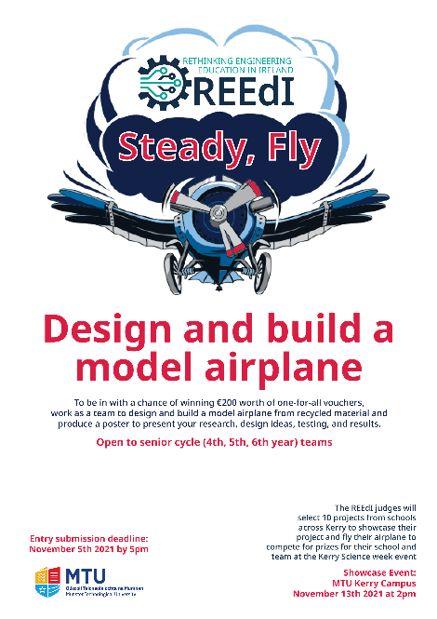

Insert pictures (maximum 8) to show the materials used, prototypes, and the finished model airplane.

Describe how you tested the model airplane.

How did you ensure the results were repeatable?

What challenges did you face?

Did you make any changes to the airplane after you tested it?

Feel free to include pictures (maximum 4)

**Design and development of a model airplane built from recycled materials**   
(School name)

(Team member 1), (Team member 2), (Team member 3), (Team member 4).

Rethinking Engineering Education in Ireland for details visit **www.reedi.ie**

Briefly state the results of the tests.

How far did your plane fly?

Feel free to include pictures (maximum 2)

Describe the research the team did for this project.

Testing

Research

Conclusion

Results

Design Ideas

Tell us what you learned from this project.